Application for HSP Clients

Your full legal name: Date:

Hello and thanks for contacting me. I know it might be challenging to reach out for help so kudos to you for asking for support. Let’s discover if we are a good fit.

There are several ways you can get to know me to decide if you would like to work with me.
- Watch my book video. I talk about the gifts and challenges of being a highly sensitive introvert by vulnerably sharing key moments of my life.

- Read my book, The Gifted Highly Sensitive Introvert, Wisdom for Emotional Healing and Expressing Your Radiant Authentic Self. Available on Amazon in paperback, kindle and audio. It’s a memoir and teaching stories to jump-start your learning.

- Read my website and blog posts: SensitiveIntrovert.com

- Listen to this meditation: A Journey Into Wholeness – A Guided Meditation MP3 Download. Or purchase a CD. Create a lifestyle with less stress and more inner peace. Our HSP nervous systems can become quickly overwhelmed. We benefit from daily downtime where our bodies experience a deep state of rest. After meditating, you’ll feel calmer and stronger. You won’t get triggered when people do things you don’t like. Use “A Journey into Wholeness” meditation to create balance in your life. It will help you reduce anxiety and stress, depressed mood, fatigue, pain, insomnia, dis/ease, and irritability. It can also help you repair damaged relationships and increase your self-worth. Make meditation a daily part of your self-care routine.

INFORMATION ABOUT SPIRITUAL COUNSELING AND LIFE COACHING

I only see clients on Zoom which is HIPAA compliant. You’ll need the following:
- a private setting so we can have a confidential session without background noise.
- a stable internet connection.
- Use your smartphone, computer or iPad to access Zoom.
- I’ll email Zoom instructions if we decide to work together.
Schedule: I see clients Monday-Thursday 10am-6pm Eastern for individual and couples’ sessions.

For faster progress than 53-minute sessions, you have four options:
- Schedule 80-minute appointments
- Attend a private personal intensive retreat.
- Attend an intensive group retreat.
- Combine individual private coaching with a class or weekly HSP group.
Computer Skills: You’ll need to be able to read my Welcome Package forms in a WORD or a PDF document. You’ll need to print forms, sign them, scan them, and return them via email. Or you could mail the forms via USPS if necessary. Please respond to my emails and/or texts within 24 hours, Monday-Thursday.

No Surprises Act Good Faith Estimate - Fees for HSP spiritual counseling and life coaching
Intake & Follow-up Ala Carte Meetings: $205 per session @ 53 minutes. Or $310.00 for 80 minutes.
After the first meeting, you may receive a discounted rate when you purchase a package.
- 6 meetings ​(53 minutes) to be completed within 3 months: $180 per session. Total $1,080. Save $150.
- 12 meetings ​(53 minutes) to be completed within 6 months: $170 per session. Total $2,040. Save $420.
HOW TO MAKE PAYMENTS: Please make your payment the day before your session or the morning of your session via Venmo. This is the only payment system that I use unless you live outside the USA, in which case I use PayPal. You may pay for multiple sessions at one time if you choose to. You could also mail a check.
Health Savings Accounts: Venmo might or might not process health savings account debit cards. You can mail me a check from your HSA account for multiple sessions. Some clients pay me and then get reimbursed by their health savings account. Talk to your employer to learn the rules that apply to you.
CANCELATION POLICY – 48 HOURS: If you can give me a week or more cancelation notice, it is most appreciated because I schedule clients at least one week ahead of time. I want to be able to fill your time slot if you cancel. Appointments broken within 48 hours must be paid in full before future sessions will be scheduled. Having said that, if you can reschedule in the same week, you don’t have to pay for a missed session.
NEWSLETTER: Would you like to receive my email newsletter? I send it at least once every 1 – 2 months. They contain educational articles about relationships, personal growth, holistic healing, and event notices.
__ Yes please, sign me up. __ No thanks.

Ready to begin?

If you would like to proceed and receive a complimentary 10-minute Discovery Call, please return the completed application below. Fill out your answers and return this entire document. Note: This does not constitute a professional relationship. We’re just getting to know each other.
Take the quiz to see how you score as a highly sensitive introvert. Email me your score, please.

Check all the formats you are interested in:
__ Private sessions for life coaching and spiritual counseling via Zoom
__ Highly Sensitive People virtual group or class
__ Intensive retreats for Highly Sensitive People
What is your full address: street, city, state, country, and zip code?
What is your email address? If you have a Gmail address, please provide it so our correspondence will be encrypted.
What is your cell phone number?

What is your age? Date of birth? month/day/year:

How did you find me? If you did an internet search, what keywords did you use?
Please write a brief paragraph for each of the following:
- Describe your personal and/or professional goals that you would like help with.
- What have you tried so far that hasn’t worked as well as you would like?
- Please tell me why you are interested in working with me as opposed to other life coaches, spiritual counselors or therapists.
Do you experience now … or have you ever experienced … any of the following:
- Severe depression, suicidal thoughts or suicidal attempts?
- Have you experienced physical, sexual or emotional abuse or other forms of trauma?
- Do you drink to excess, use drugs without a prescription, or use recreational drugs?
- Do you experience any other addictions, an eating disorder or bipolar symptoms?
- Have you ever attended an in-patient treatment center for emotional or substance abuse issues?
- Have you ever had a psychiatric diagnosis? If so, what?
- Have you ever had legal trouble other than parking tickets? Possible upcoming court cases?

If you think we might be a good fit …

- Please email your answers to all these questions to Benita@SensitiveIntrovert.com.
- I will reply within 48 hours Monday-Thursday. If you don’t hear from me, please contact me again. There might be a technical glitch.
- I offer a complimentary 10-minute Discovery Call Monday-Thursday. If you want to proceed, please email me with three days and times you can talk on the phone or meet on Zoom.

I look forward to hearing from you soon.
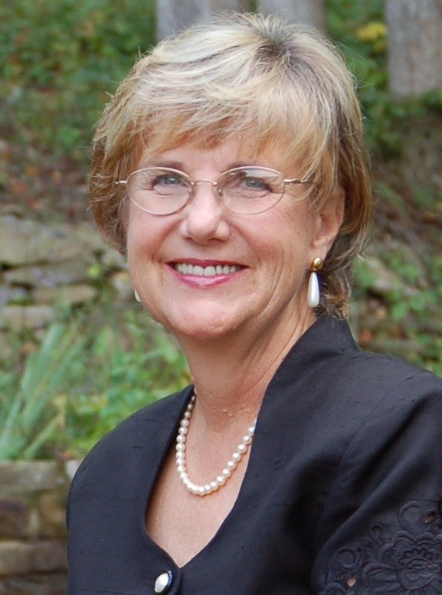
Bright Blessings,

Benita A. Esposito, MA
Life Coaching and Spiritual Counseling - Globally

Email: Benita@EspositoInstitute.com

www.SensitiveIntrovert.com

Psychotherapy in GA and NC
www.Flourishing-Lives.com

Cell: 770 998 6642

